**Project title:**

**Team name:**

**Team type:**

**Team members:**

**Executive Summary**

Has your research advisor ever asked you to "whip up a quick report before the end of the day"? You say yes with a sinking heart — because you know it is not going to be quick. The founder of my company, Quick Report Inc., dealt with this issue many times as a Ph.D. student. So, he created an online tool that puts all your data in one place and makes a professional-looking report in 30 seconds or less.

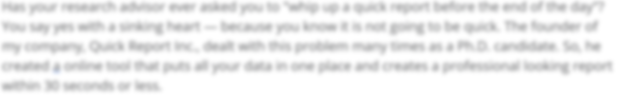

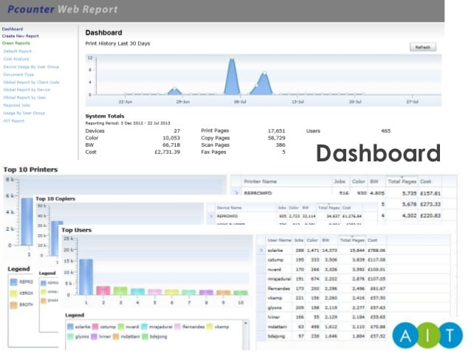

Figure 1: screenshot

Figure 2: diagram

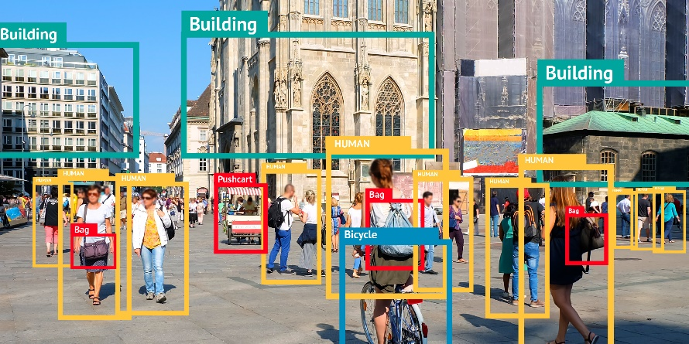

Figure 3: expected results